

Capstone Project Report
Report 4 – Software Design Document

– Hanoi, August 2019 –

Table of Contents
I. Record of Changes 3
II. Software Design Document 4
1. System Design 4
1.1 System Architecture 4
1.2 Package Diagram 8
2. Database Design 9
3. Detailed Design 9
3.1 Common Structure — Command, Handler and Pipeline 9
3.2 Ticket Purchase 10
3.3 Donation and Performer Payout 11
3.4 Content Moderation 12

I. Record of Changes
Date | A*  M, D | In charge | Change Description
27/06/2026 | A | Hà Đông Hải | Software Design Document for the complete platform: backend layering, frontend structure, deployment on Microsoft Azure, the 68-entity data model and the detailed design of the principal flows.
*A - Added M - Modified D - Deleted

II. Software Design Document

1. System Design

1.1 System Architecture
The backend follows Clean Architecture across four projects with a strict inward dependency rule — Api depends on Application and, at the composition root only, on Infrastructure; Infrastructure depends on Application; Application depends on Domain; and Domain depends on nothing. The rule is enforced at the project-reference level rather than by convention, so a violation fails the build instead of passing review.
Domain holds entities, enumerations, domain events and exceptions as plain C# with no framework reference, which is what makes every business rule in it testable with no database and no host. Application holds all business logic as command and query handlers, one folder per business area (28 of them), with cross-cutting concerns — validation, transaction boundary, logging — implemented once as pipeline behaviours rather than repeated in every handler. Infrastructure implements every interface Application declares but does not itself implement: the database context and repositories, an adapter per external service, and the 30 background job classes. Api is deliberately the thinnest layer: 25 controllers exposing about 209 endpoints that authenticate and authorise the caller, map the request onto a command or query, and return the result — no business logic lives in a controller.
This split exists for two concrete reasons rather than architectural fashion. First, Domain and Application can be tested with no database, no HTTP host and no external service running. Second, an external integration can be replaced without touching a single handler, because Application depends only on the interface and never on the concrete adapter — which is how the SMS provider was swapped without changing business code.
All 5 client surfaces sit outside the backend entirely and consume only the Api layer, over REST and WebSocket. No client ever reaches Infrastructure, Application or Domain directly.
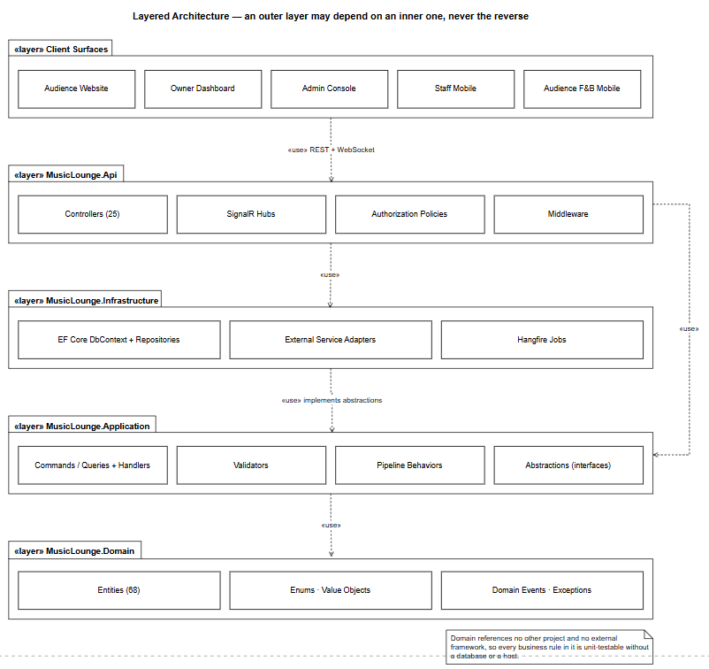
Figure 1 — Layered architecture — an outer layer may depend on an inner one, never the reverse
The five client applications are separate deliverables but not five unrelated codebases: they share one design system, one API client generated from the API's own contract, and one set of cross-cutting conventions, so a contract change propagates to every consumer as a compile error rather than a runtime failure in one of them. The three web surfaces are React with TypeScript; the two mobile surfaces are React Native sharing the same models and client.
Within each surface the layering is the same. Screens and routes are the only layer that knows about navigation; a route guard resolves the caller's role and redirects before rendering, which is a usability measure and never the security boundary, since the API re-checks every request independently. Feature modules mirror the backend's folders one for one, so a developer tracing a defect moves between tiers without learning a second vocabulary. State is split deliberately: anything the API owns lives in the query library, which handles caching, retry and invalidation, and only genuinely client-owned state lives in a local store.
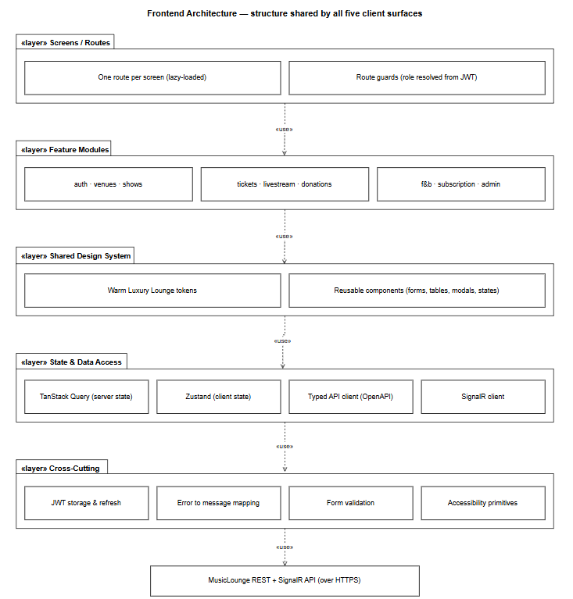
Figure 2 — Frontend architecture — the structure shared by all five client surfaces
The platform is deployed to Microsoft Azure. The three web bundles are served as static assets from the edge, so a page load costs the API nothing. The API and its real-time hubs run on an application host with the background worker in the same process, behind a staging slot that is warmed and smoke-tested before being swapped into production — which makes a rollback a swap back rather than a redeploy. The imaging microservice runs separately because its workload is different in kind: bursty, processor-bound, and dependent on native binaries, so it scales on its own and a stitching failure cannot destabilise the API host.
Uploaded media is stored in blob storage and served through a content delivery network, keeping image traffic off the API entirely. Every secret is held in a managed vault and injected at deploy time, so no secret exists in source control or inside a build artefact. Telemetry, background-job outcomes and alert rules are collected centrally.
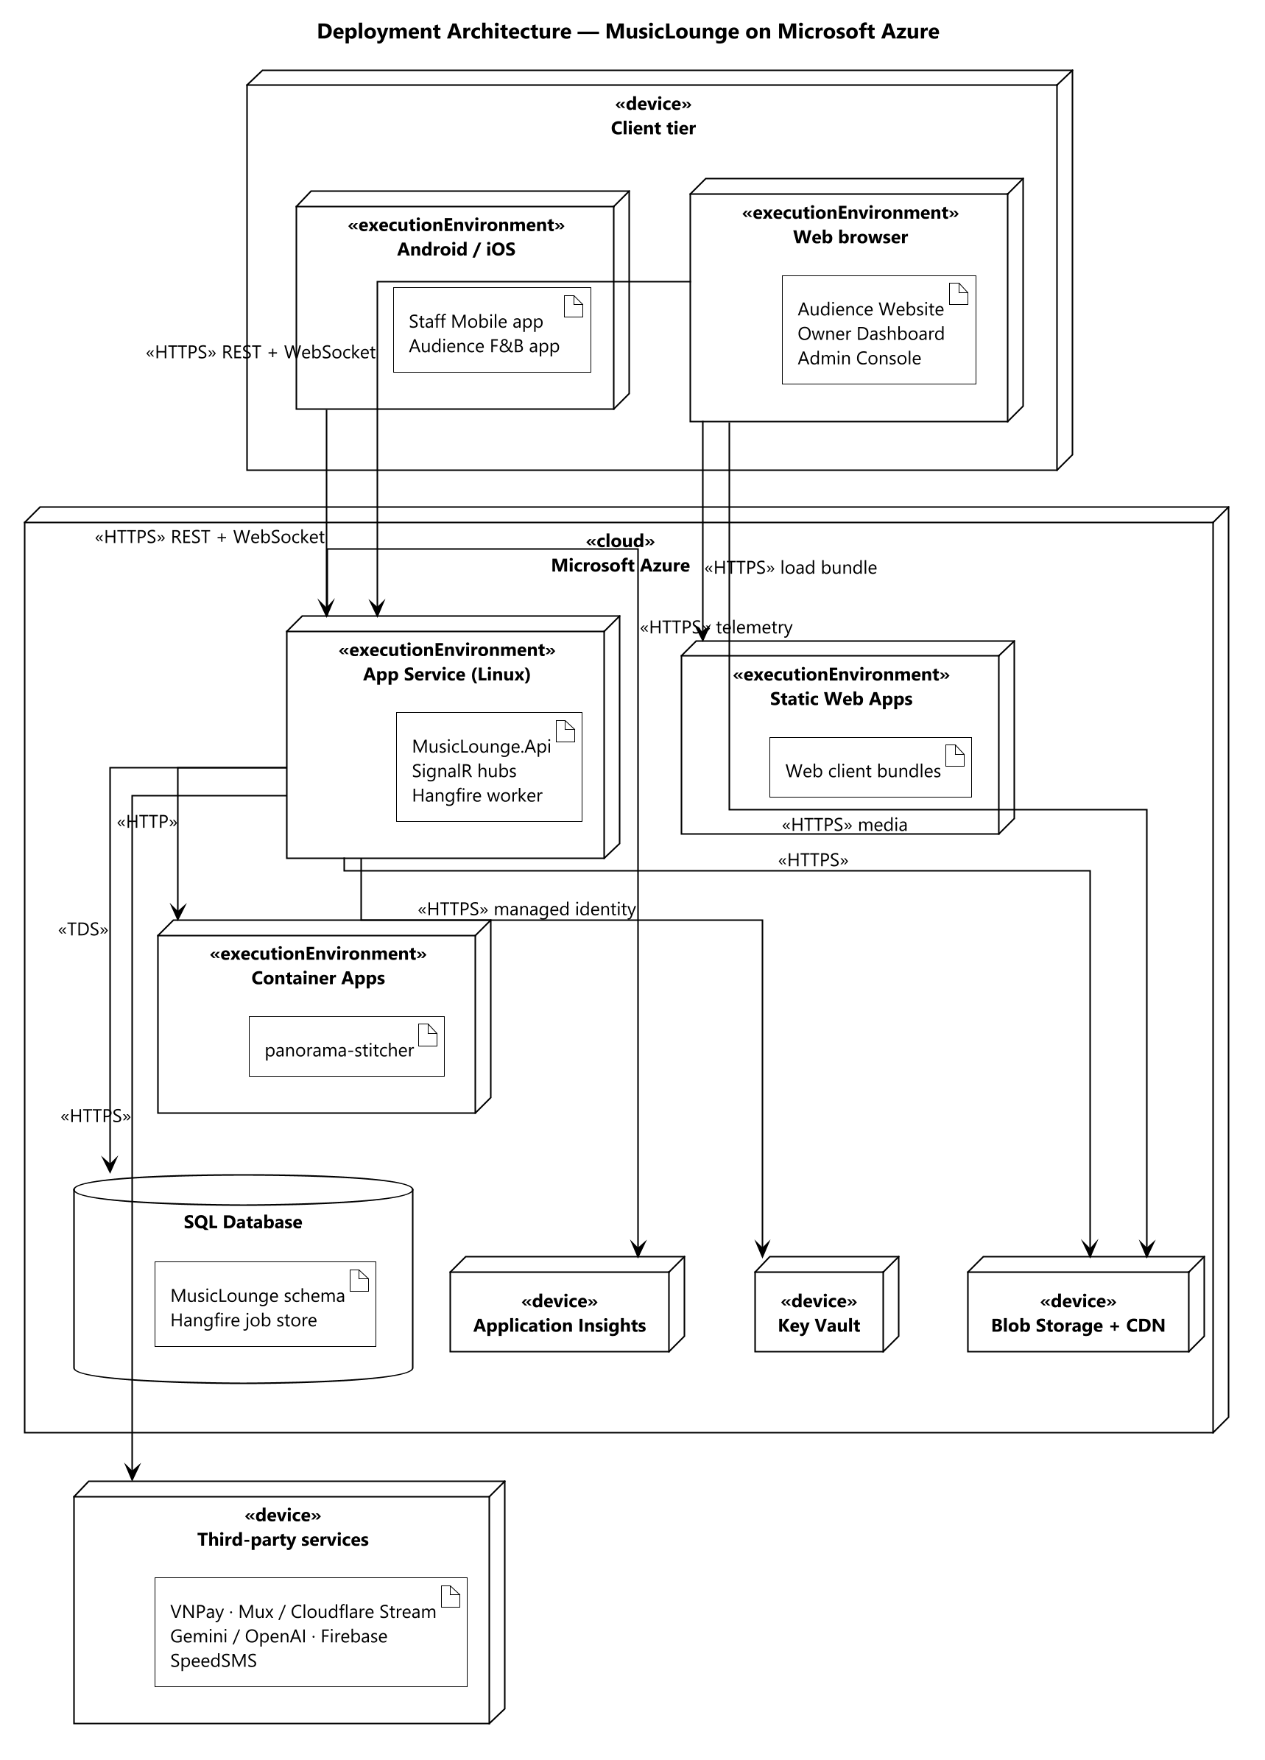
Figure 3 — Deployment architecture — nodes, the artefacts deployed on them, and the protocols between them

1.2 Package Diagram
The table below describes every package in the four backend projects, using dotted Project.Package notation. The frontend's internal structure is covered above rather than repeated here.
No | Package | Description
1 | Domain.Entities | The 68 entity classes that make up the business data model.
2 | Domain.Enums | Closed sets of values — statuses, roles, payment and moderation states — persisted as strings so the database stays readable.
3 | Domain.Events | Domain events raised by an entity when something business-significant happens, handled asynchronously.
4 | Domain.Exceptions | Business exception types that map to specific HTTP responses at the boundary.
5 | Domain.Common | Shared base types, principally the entity base with its identifier and audit fields.
6 | Application.<Feature> | One folder per business area (28 in total), each holding its commands, queries, handlers, validators and data-transfer objects.
7 | Application.Common.Abstractions | The command and query marker interfaces the mediator dispatches on.
8 | Application.Common.Interfaces | Every capability Application needs but does not implement: unit of work, repositories, payment, livestream, messaging, AI and imaging services.
9 | Application.Common.Behaviors | Pipeline behaviours that wrap every handler: validation, transaction boundary and logging.
10 | Application.Common.Models | Shared result and paging shapes returned across features.
11 | Infrastructure.Persistence | The database context exposing the entity sets, one configuration class per entity, the migration history, and the concrete repository and unit-of-work implementations.
12 | Infrastructure.Services | One adapter per external system — payment, livestream, AI, push, SMS, email and imaging — each implementing an Application interface.
13 | Infrastructure.Jobs | The 30 background job classes, 22 of which run on a recurring schedule.
14 | Infrastructure.Security | Token issuing, password hashing, and the protection of sensitive stored fields.
15 | Api.Controllers | The 25 controllers exposing roughly 209 endpoints.
16 | Api.Hubs | Real-time hubs for livestream chat, access gating and the public donation ticker.
17 | Api.Authorization | Policy definitions and the venue-scoping requirement handlers.
18 | Api.Middleware | Global exception handling, request logging and security headers.

2. Database Design
68 entities are mapped to SQL Server tables entirely through Code-First migrations; there is no hand-written schema script, so the schema in any environment is whatever the committed migration history says it is.
Conventions applied consistently across the schema. Identifiers are integer identity columns, except Ticket, whose key is a server-generated sequential globally unique identifier so a ticket cannot be found by guessing a number. Enumerations are stored as their string names rather than ordinals, so a value stays readable in the database and inserting a new member cannot silently renumber existing rows. Money is stored as a fixed-precision decimal, never a floating-point type. Timestamps are stored with their offset. Deletes are restricted by default; a cascade is only configured where the child genuinely has no meaning without its parent, which also avoids the multiple-cascade-path restriction on the real engine.
The relationships between the core entities are shown in Report 3 §3.1.5. The remaining tables fall into four groups: taxonomy tags and the join tables that attach them to shows, performers and user preferences; financial records — accounts, ledger entries, payments, settlements, refunds and bank accounts; operational logs for sign-in failures, push failures and behaviour events, each with its own retention rule; and configuration, where every business-tunable number lives with an audit trail of changes.

3. Detailed Design
Every feature repeats the same class structure, so it is documented once in §3.1 rather than redrawn per feature. The sections after it give the sequence of the flows where the interaction, not the class shape, is what carries the design risk.

3.1 Common Structure — Command, Handler and Pipeline
A controller action does nothing beyond authorisation and mapping: it builds a command or query and hands it to the mediator. A validator declared alongside the command is run by a pipeline behaviour before the handler is reached, so a handler never begins with a block of argument checking. The handler depends only on interfaces — the unit of work, and a specific repository where a query needs eager loading — so it can be exercised without a database. A transaction behaviour opens and commits around the handler, which is why a handler never manages a transaction itself and why a failure part-way cannot leave a half-written change.

3.1.1 Class Diagram
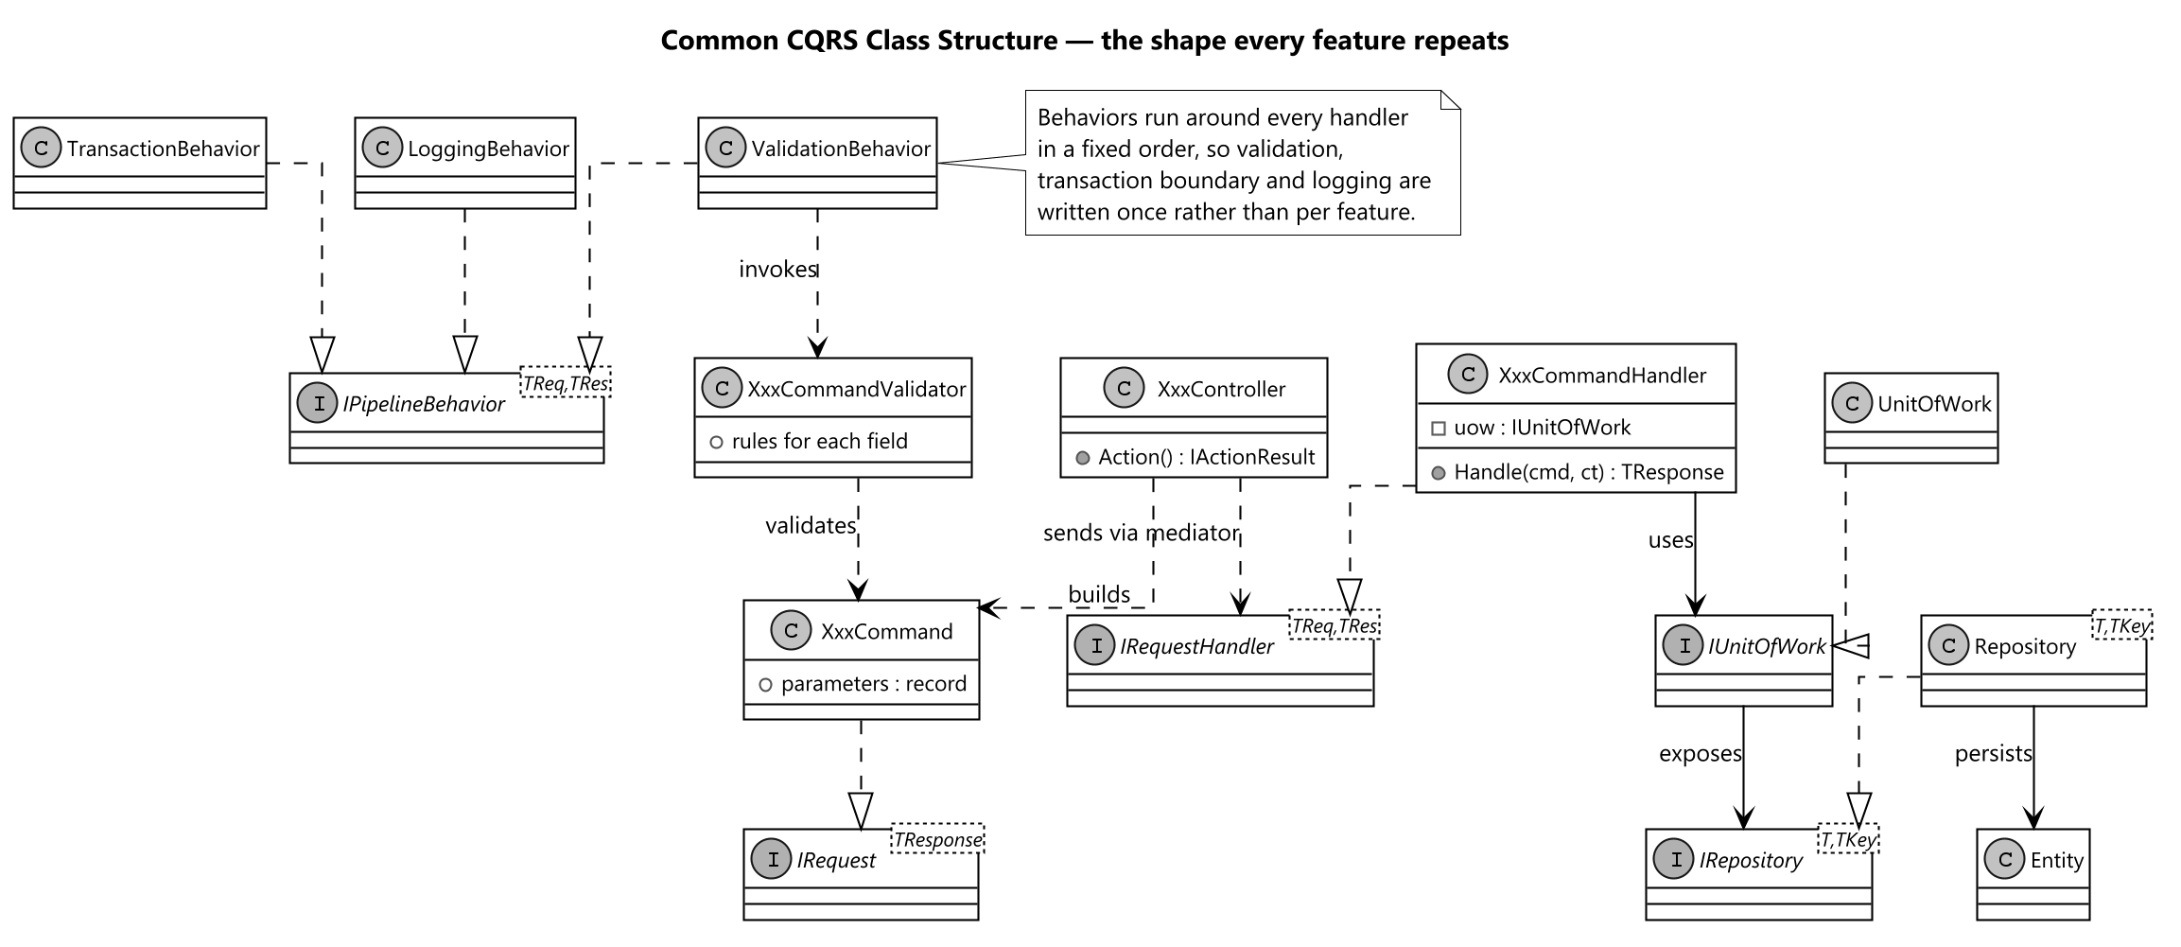
Figure 4 — Common CQRS class structure repeated by every feature

3.2 Ticket Purchase
This is the flow with the most concurrency risk in the system, so it is designed around two decisions. Capacity is decremented when the hold is taken rather than when payment completes, which is what prevents the same seat being sold twice during the payment window. And the gateway's server-to-server callback, not the browser redirect, is treated as the authoritative confirmation — so the ticket still confirms if the customer closes the tab, and the handler must be idempotent because the gateway retries until it receives the response it expects.
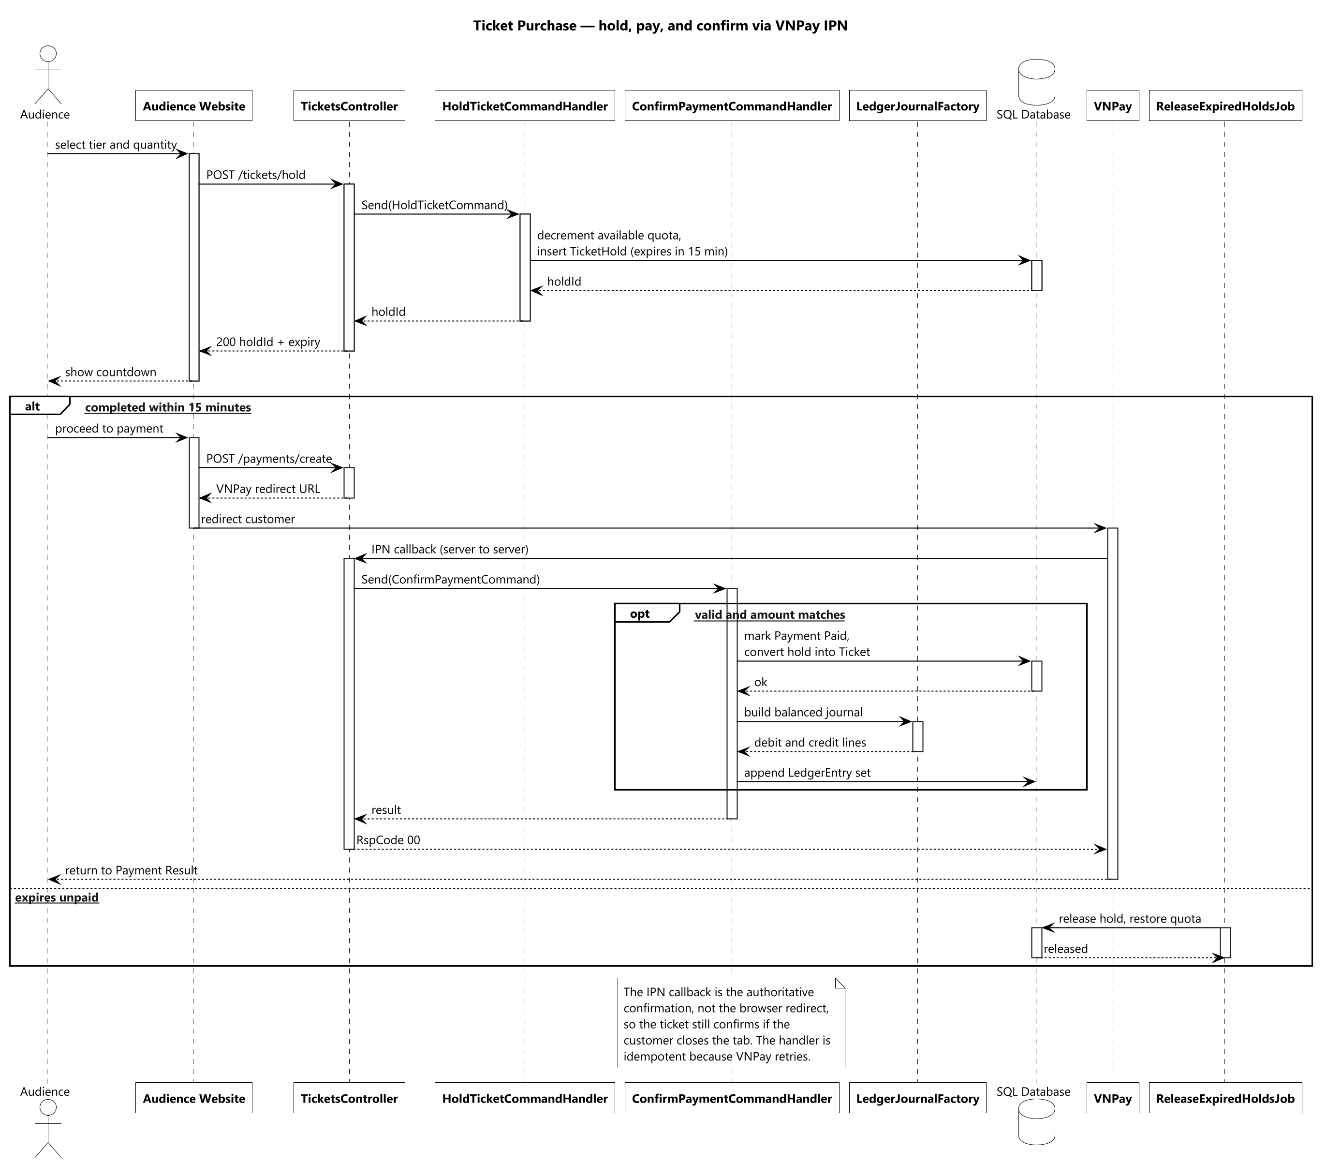
Figure 5 — Ticket purchase — hold, pay, and confirm through the gateway callback

3.3 Donation and Performer Payout
A tip is not a single transfer but a pipeline that can span days, and the design makes each stage explicit rather than hiding the delay. At confirmation the platform commission and tax are posted immediately and the performer's share rate is frozen onto the donation, so an administrator adjusting the rate afterwards cannot change what an existing donation already promised. The final payout is refused outright if the performer has no registered bank account, because recording a payout with no destination would leave the ledger claiming money moved somewhere that does not exist.
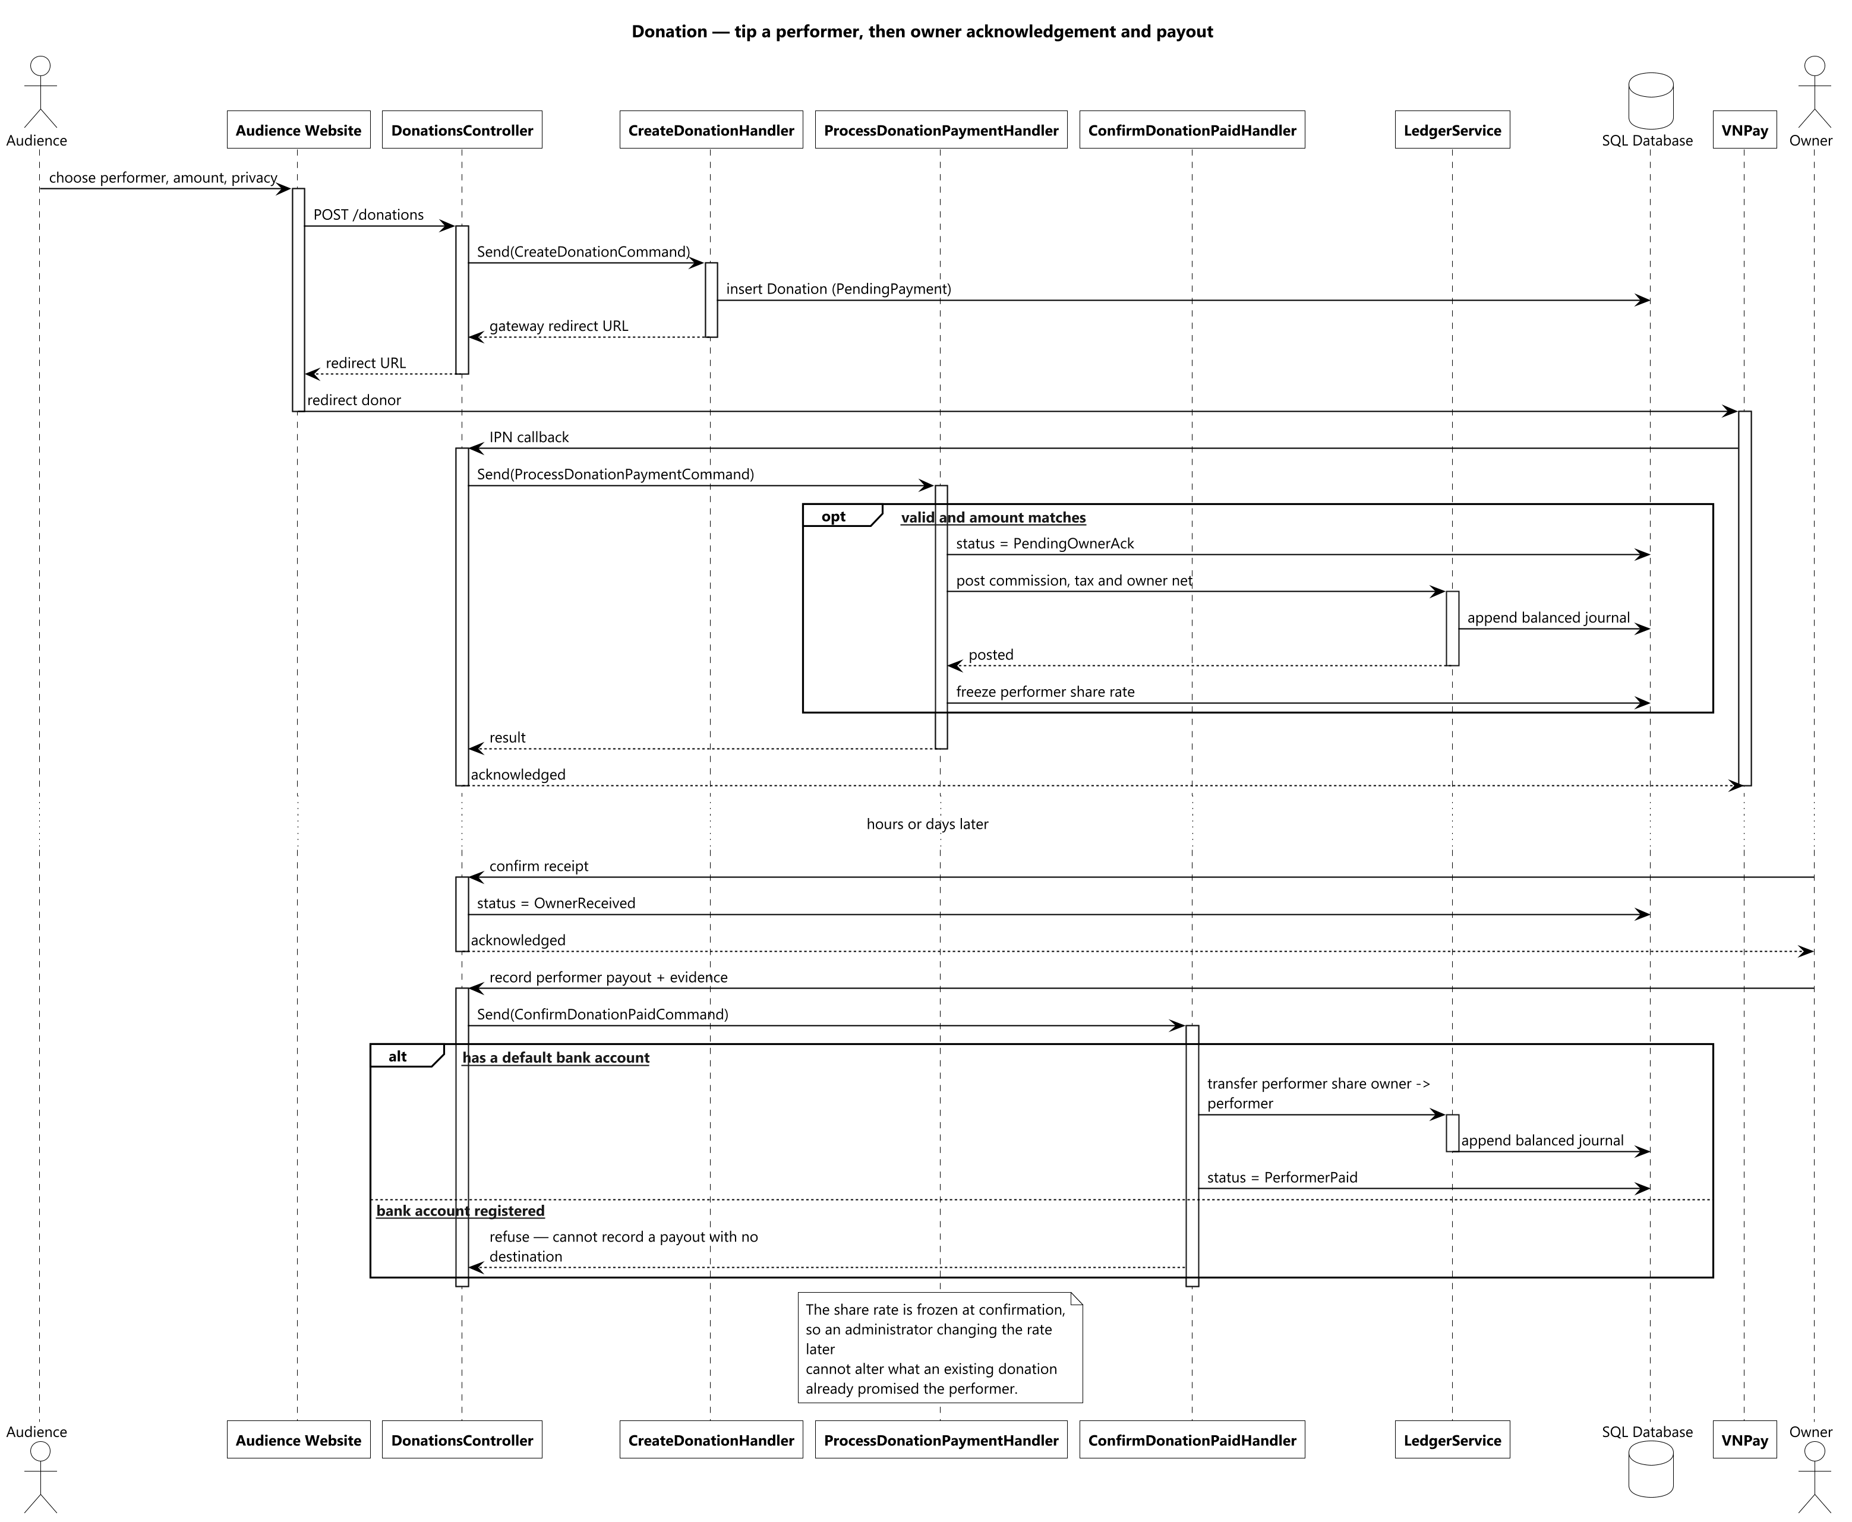
Figure 6 — Donation — tip a performer, then owner acknowledgement and payout

3.4 Content Moderation
The design deliberately separates advice from authority. Scoring runs as a background job so a slow or unavailable AI service cannot block a submission, and its output is a score and a recommendation that an Admin may follow or ignore. If the service fails the item still enters the queue with a neutral score, because the failure mode that matters here is content never reaching review at all — not content reaching review without a score.
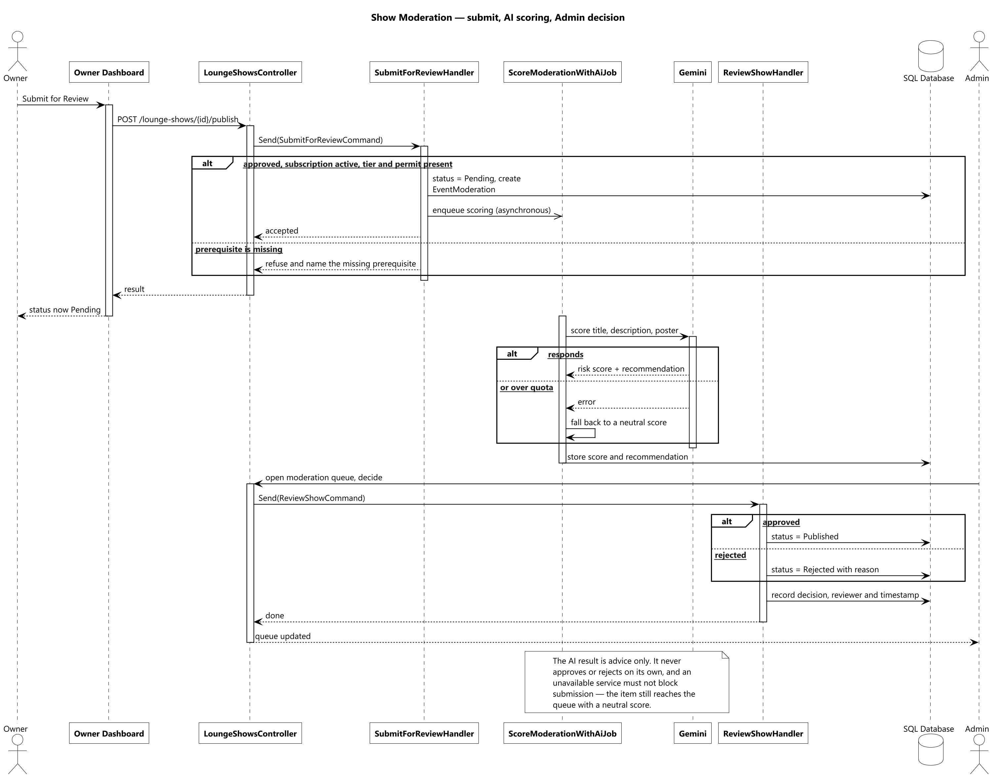
Figure 7 — Show moderation — submit, AI scoring, and the Admin decision

